# **Master_U1 LED Driver**

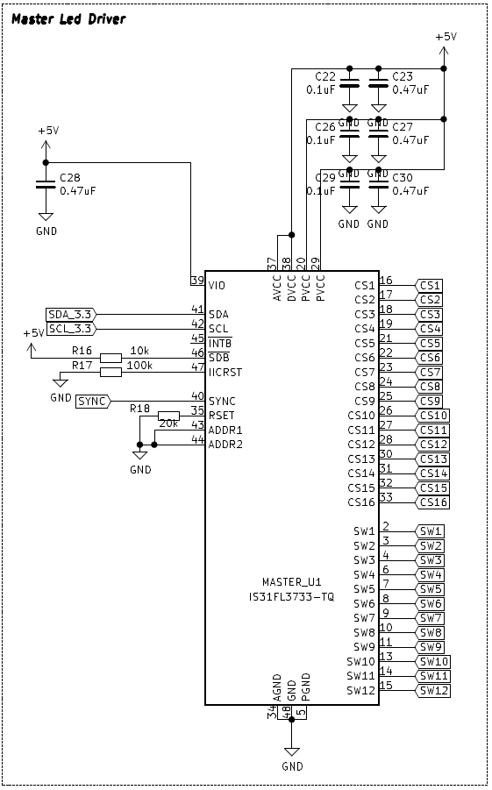

**R16 should be 100k**

# **Slave_U1 LED Driver**

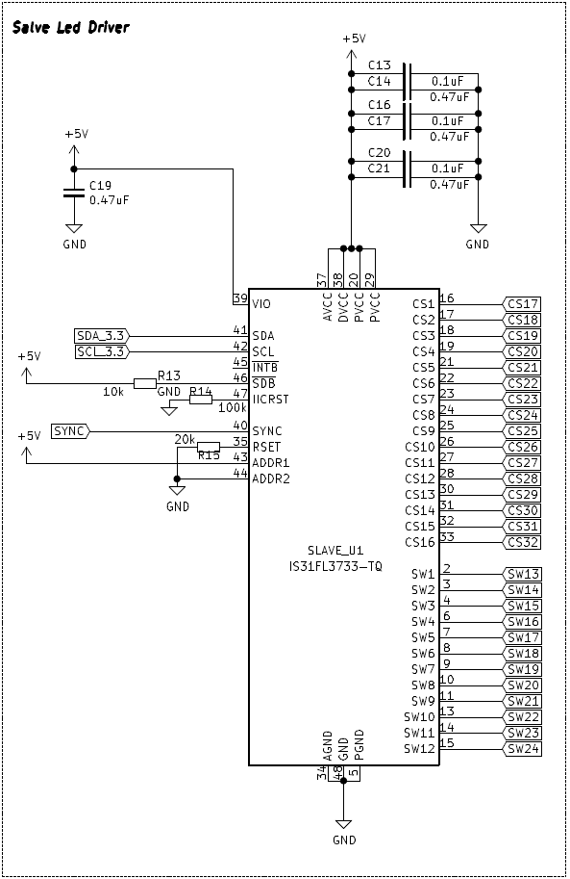

**R13 should be 100k**

# **OLED Driver**

**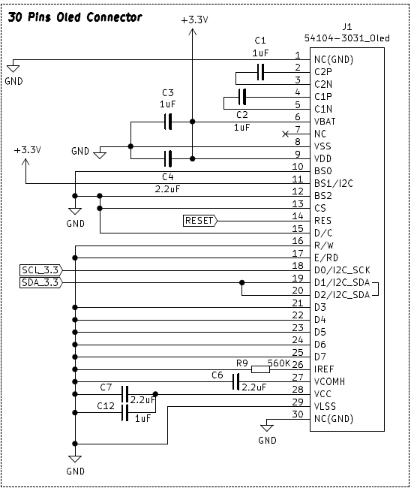  
Connect the NC (pin 7) to GND**

# **I2C Level Shifter**

**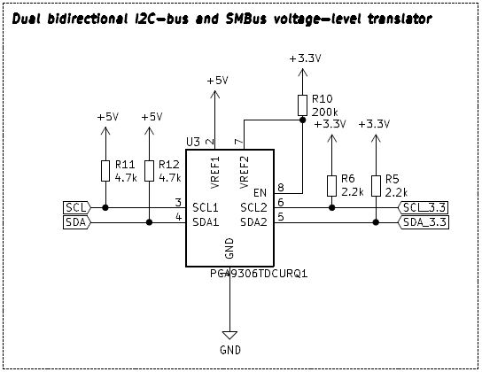  
Swap +5V and +3.3V for all signals, this may be on breadboard.**

**Should look like this   
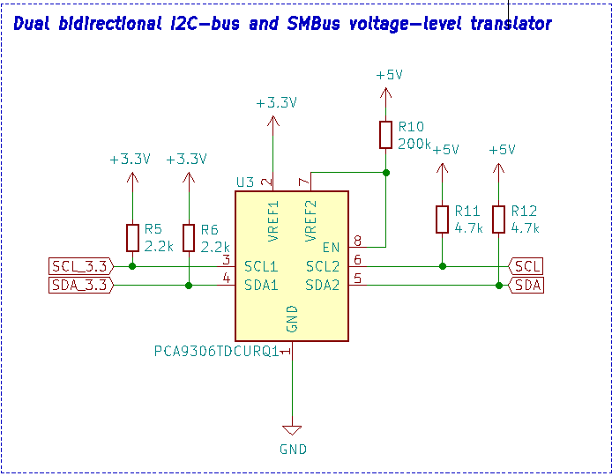**

# **I2C Connections**

**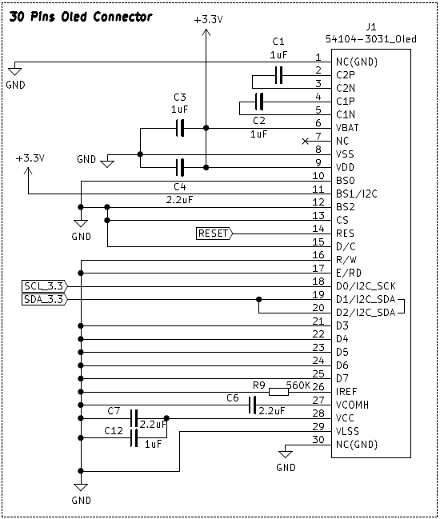  
Connect pin 18 to new voltage-level translator SCL_3.3.  
Connect pin 19 and pin 20 to new voltage-level translator SDA_3.3.**

**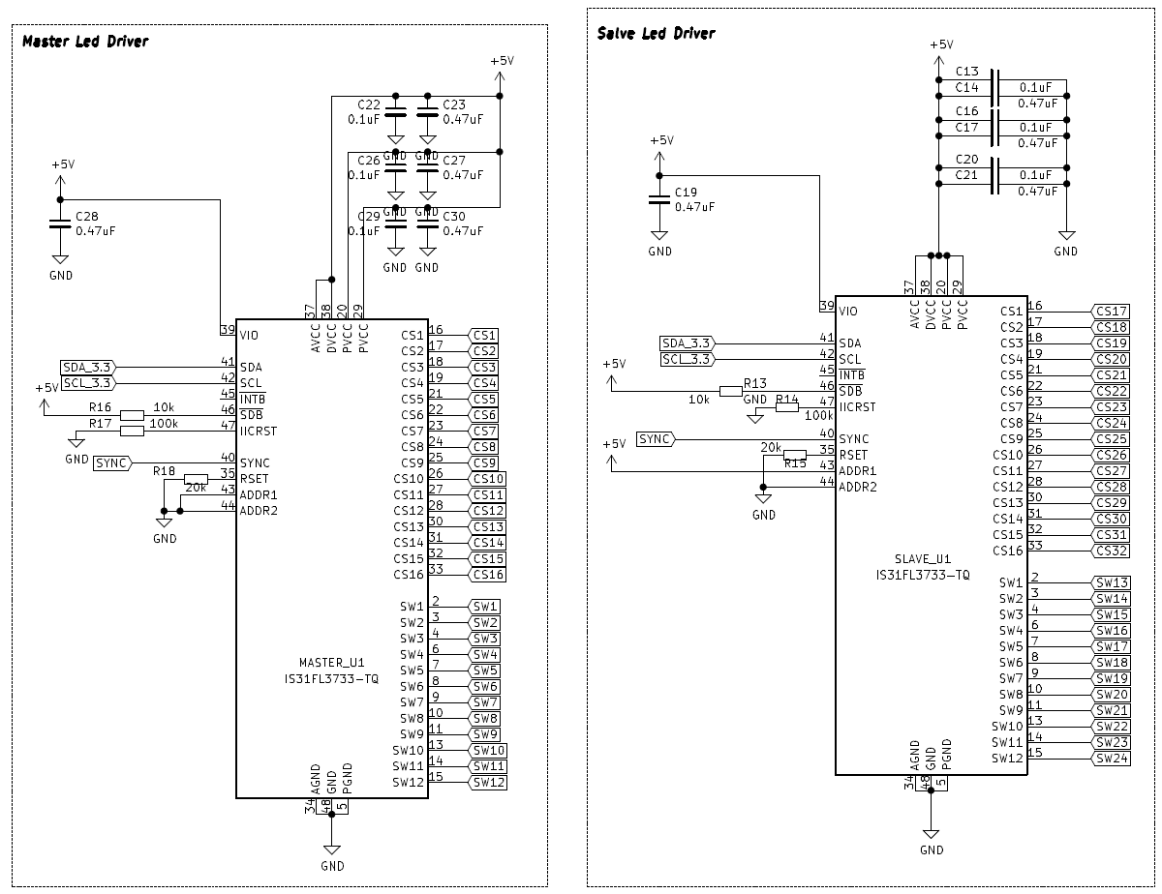  
Connect pin 41 on both Master and Slave together to new voltage-level translator SDA.  
Connect pin 42 on both Master and Slave together to new voltage-level translator SCL.**